Client project information manager
Scope of Services
Invitation to Tender (ITT)
[Insert Project Name]
[Insert Contracting Authority/ Organisation]
[Revision]
[Date]

This document has been produced in response to the development of the SFT Standard information management plan (SIMP) for public sector bodies in Scotland.
This document offers a best practice approach to the procurement of client project information management services in accordance with BS EN ISO 19650 parts 1 and 2 – Information management using BIM, on new public sector projects.
Produced for Scottish Government by Scottish Futures Trust and in partnership with Industry and Public Bodies.
Published by Scottish Futures Trust
Date: 18th May 2020
Document reference: SIMP-SFT-XX-XX-SC-Z-0001
Status: S2- Suitable for information
Revision: P03

Scottish Futures Trust
11-15 Thistle Street
Edinburgh
EH2 1DF

Notes for User of Template
Context on the role
This Invitation to Tender (ITT) outlines the scope of services for the delivery of project information management services to support the client organisation/ contracting authority during the project delivery phases.
Dependant on the level of expertise and experience available, the appointment can be with a 3rd party BIM/ Information management consultant, or an additional service to an existing project party appointment. The skill set and experience required is focused on information management using BIM in accordance with BS EN ISO 19650 parts 1 and 2 – there is no design responsibility or design liability.
This scope of service does not cover BIM co-ordinator duties, which typically undertakes coordination and clash detection in connection with 3D models. Coordination and clash detection are part of the design coordination activities undertaken by the design team lead and is excluded from this scope.
The following scope of services should be reviewed against the Project information protocol to ensure alignment. Where a client organisation/ contracting authority has specific templates, these can be referred to within section 3.3 herein.
This template document assumes that all text in blue italics is guidance and should be deleted from the final ITT. All [red text] requires population by the user in the development of the ITT.
BIM readiness prior to tendering a client project information manager
Please note that this client project information manager scope of services template has been developed on the assumption that the client organisation/ contracting authority have already begun to develop a BIM strategy, associated project BIM documents and adopted the SFT Standard information management plan (SIMP). The SIMP project information strategy dashboard should be completed as preliminarily and included in Appendix C of this ITT before issuing to prospective tenderers.

Contents

- Introduction

- Submission of ITT Response

- Project Details and Definitions

- Scope of Works

- Quotation Submission Requirements and Evaluation Criteria

- Fee Proposal

Appendices

Appendix A Standard Form Information Management Plan overview
Appendix B Information management assignment matrix
Appendix C Project information strategy dashboard
Appendix D Terms & Conditions

Introduction
This invitation to tender (ITT) outlines the scope for the provision of professional client/ contracting authority project information management services for the [insert project name] on behalf of [insert organisations name]
Scottish Government is committed to embedding and realising the recommendations of the “Review of Scottish Public Sector Procurement in Construction”. The review committed that:
“BIM will be introduced in central government with a view to encouraging adoption across the public sector. The objective should be that, where appropriate, projects across the public sector adopt BIM level 2 by April 2017.”
The services required and provided shall be in accordance with BS EN ISO 19650 parts 1 and 2: information management using BIM standards and processes. Further details can be found via the SFT BIM Portal: https://bimportal.scottishfuturestrust.org.uk/ and the UK BIM Framework website https://ukbimframework.org/

- Submission of ITT Response
Tenderers must submit their tender responses no later than [XX.XX] on [XX/XX/XXXX] electronically to [XXXX]. Any tender response not received in full by this deadline may be rejected. [insert organisations name] may at its own discretion extend this closing date and the time for receipt of tender responses. Any extension granted under this paragraph will apply to all tenderers.
Tender responses should remain open for acceptance for a period of XX days from the deadline for receipt of responses specified above. A tender response valid for a shorter period may be rejected.

- Project Details and Definition
  - Project Summary
Project Data
Project Name | Insert name of project
Project Description | e.g. text description taken from NPR
Project Address | Name, Address and Postcode
Correspondence Address | Name, Address and Postcode
Procurement approach | e.g. traditional, DB, DBFM
Project Value | £ (value) – note also if this is net or gross
Contract Type | e.g. NEC3
Plan of Works | e.g. RIBA 2013, GRIP etc.
Relevant project stage(s) | e.g. RIBA Stage 2-6
Estimated number of Info delivery milestones | [from initial completion of dashboard by client]
Estimated number of lead appointed party’s | [from initial completion of dashboard by client]
Procurement Timetable, Key Dates and Meetings
The planned timescales for this information management procurement exercise are as follows:

Confirm intention to quote | xx/xx/xxxx
Last date for queries | xx/xx/xxxx
Submission date | xx/xx/xxxx
Evaluation and select supplier | xx/xx/xxxx
Initial meeting with selected supplier | xx/xx/xxxx
Commission commences | xx/xx/xxxx
Commission completed | xx/xx/xxxx
[Insert any regular meetings that the supplier should attend and frequency / location of same] | xx
[If CDE platform hosting services are required from the project information manager key associated dates / time periods should be established here if known, e.g. mobilisation, archive period for storing data post-handover] | xx
Named contact for this procurement is:
Name | xx
Address | xx
Telephone | xx
E-Mail | xx

  - Definitions
Lead appointed party: an ISO 19650 term for a provider of information concerning works, goods, or services. The lead appointed party is directly appointed by the appointing party. Examples include Architect, Engineer, Project Manager, Contractor.
Appointing party: an ISO 19650 term for a receiver of information concerning works, goods or services from a lead appointed party. This is typically, but not limited to be the client / contracting authority, employer, or owner.
Appointed party: an ISO 19650 term for a party appointed on a project to provide information concerning works, goods or services. The appointed party is directly appointed by the lead appointed party. Examples include specialist sub-consultants and/ or sub-contractors.
Common data environment (CDE): a process workflow and digital solution which enables the management of information (information containers) during the delivery and asset management stages of a project. During the delivery phase the CDE solution and workflow support the information management process and the development of a federated information model in accordance with ISO 19650-2, clause 5.6, 5.7, and the National Annex NA.
Information container: information file (e.g. model, document, table, schedule) or a sub-set of a information file (e.g. chapter, section, layer, symbol)
Information delivery milestones are established deadlines (dates) by the appointing party for required information deliverables, aligned to the project’s plan of work (stages) and key decision points.
Information standard: means BS EN ISO 19650-1 and BS EN ISO 19650-2 as may be amended or superseded from time to time.
Project information protocol: an agreement (legal contract) between an appointing party and a lead appointed party and included within each appointment. The project information protocol is also included within all lead appointed party sub-appointments throughout the delivery team(s).
Project information requirements (PIR): defined by the appointing party to establish the information needed to answer or inform high level strategic objectives in relation to the purpose, design and construction of an asset. They are identified from both project and asset management processes and inform the exchange information requirements. A set of information requirements are prepared for each appointing party key decision points.
Asset information requirements (AIR): are relative to the operation and maintenance of an asset and set out the detailed information needed by the appointing party to effectively manage a physical asset during its lifecycle. During design and construction stages the project AIR will form part of the EIR to deliver related information for asset handover and onward operational management purposes.
Exchange information requirements (EIR): derived from the project and asset information requirements as information to be delivered (exchanged) by respective lead appointed parties to the appointing party (client) at key project delivery milestones. Each EIR is appointment specific and forms part of the invitation to tender pack for each lead appointed party.

  - Required Templates
When delivering these services, the bidder for [insert project name] should adopt the following template documents:
- SFT Standard Information Management Plan (SIMP). Refer to links in appendix A.
[Insert link to other documents to be adopted by bidder e.g. SFT SIMP project information strategy dashboard, templates, CAFM import sheets]

Scope of Works
The information manager will play a key role in supporting the client / contracting authority implement and successfully deliver the Standard information management plan (SIMP) in accordance with BS EN ISO 19650 parts 1 and 2. To support the appointment process this scope of services has included a range of principle tasks to be delivered at key stages of the project.
One principle task is to ensure the project SIMP is aligned to the client/ contracting authority’s project information requirements (PIR) and then apportioned for each lead appointed party appointment, as illustrated below.
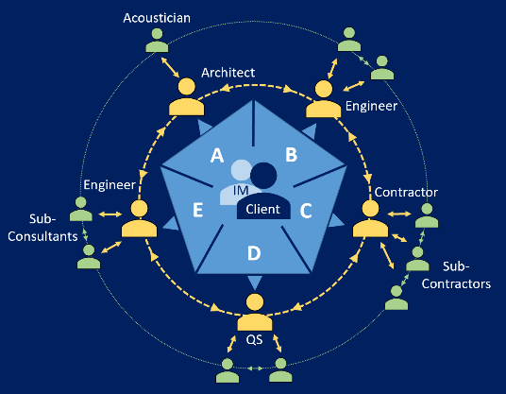

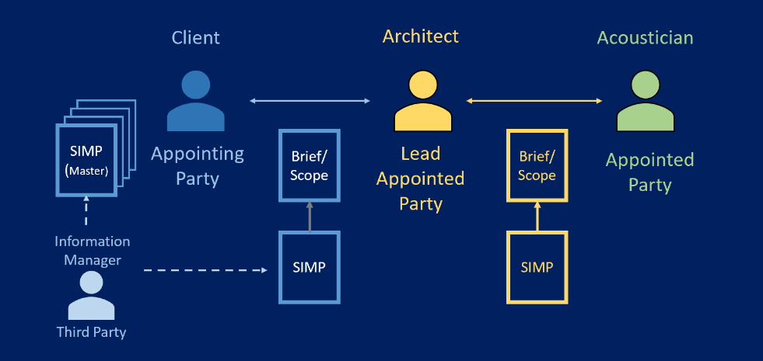

The scope of services seeks to ensure four high level deliverables: -
- support the client establish a project SIMP including project and asset related information requirements.
- develop and manage sets of project information requirements for each lead appointing party for inclusion within each appointment.
- validate the project team’s information deliverables at key delivery milestones.
- enable the delivery of accurate as-built digital information models & an O&M manual to support lifecycle asset management.
Appendix B includes an Information management assignment matrix which outlines standard information tasks to be performed on a project in accordance with BS EN ISO 19650-2, Annex A. In conjunction, the below table sets out a range of tasks to be delivered by the client information manager on this project:
1.0 Project Standard Information Management Plan (SIMP)
Establishment of the project SIMP incorporating the project information strategy dashboard, IM workbook, appendices, and relevant templates.
Ref | Task | Notes
1.1 | Review and update the preliminary project information strategy dashboard (appendix C herein) in collaboration with the contracting authority/ appointing party. | One meeting
1.2 | Working with the contracting authority / appointing party: commence set-up and population of the project Standard information management workbook and appendices.  In accordance with BS EN ISO 19650-2, this will include clauses 5.1.4: the information standard, 5.1.5: information production methods and procedures, and 5.1.6: reference information and shared resources. | Engagement meeting(s) required
1.3 | With reference to 1.2 above, agree and develop the required templates for use with the workbook.
1.4 | With reference to 1.2 above, support the development and delivery of high-level Project information requirements aligned to key decision points and corresponding information delivery milestones. | (e.g. RIBA stages)
1.6 | With reference to 1.2 above, liaise with the contracting authority / appointing party in-house FM team (or FM advisor) to establish the baseline Asset Information Requirements (AIR) and O&M manual criteria. Update the workbook and appendices. [Utilise Standard information management workbook Appendix A2 & A3. Option to utilise SIMP workbook template T3, T4 and T5] | Engagement meeting(s) required
1.7 | In accordance with BS EN ISO 19650-2, clause 5.1.8 support the contracting authority / appointing party establish the Project’s information protocol [include this task if a Project information protocol is not already established by the contracting authority / appointing party. Option to utilise UK BIM framework Information protocol template]
2.0 Project common data environment strategy (CDE)

In accordance with BS EN ISO 19650-2, clause 5.1.7, work with the contracting authority / appointing party to establish the project CDE. The CDE should be informed by Section 4.0 of the fully populated and updated project information strategy dashboard (task 1.1). The SIMP workbook and relevant appendices/ templates should be updated to record the outcomes and requirements.
Ref | Task | Notes
2.1 | Working with the contracting authority / appointing party: establish a high-level project CDE strategy to suit all project stages and procurement route. Consider technology hosting, management, licensing, and IT support requirements. [Refer to Section 4.6, SIMP workbook. Utilise SIMP workbook template T2] | This should include the adoption of template T2 - Appointing Party Information Container Hierarchy for client information exchange and storage.
2.2 | With reference to 2.1 above, establish the appointing party and lead appointed party’s accessibility requirements during the design, construction, handover, and operational phases.
2.3 | With reference to 2.1 above, establish the approach for sharing and approving information containers between the appointing party / lead appointed parties at each project information delivery milestone. [Refer to Section 5.1 and 5.2, SIMP workbook.]
3.0 Exchange information requirements for each lead appointed party

In accordance with BS EN ISO 19650-2, clause 5.2.1 establish the exchange information requirements for each lead appointed party (LAP) and appointment. Assume [XX] number of LAP’s based on the populated and updated project information strategy dashboard (task 1.1)
Ref | Task | Notes
3.1 | Work with the contracting authority / appointing party to establish the project exchange information requirements for each lead appointed party at each information delivery milestone. Update the Standard information management workbook and relevant appendices.  [Utilise SIMP workbook Appendix 1] | Engagement meeting(s) required
3.2 | Support the contracting authority / appointing party to establish prospective lead appointed parties tender pack(s) including the response requirements and evaluation criteria.
3.3 | Support the contracting authority / appointing party review of tender responses from each lead appointed party (including the pre-appointment BEP) and advise on compliance and suitability.
3.4 | Support the contracting authority / appointing party review of the required appointment level information (including the BEP) received from each lead appointed party and their delivery team(s) and advise on compliance and suitability.
4.0 Information delivery milestones – Information (model) review & acceptance

Review the information deliverables for each lead appointing party in accordance with BS EN ISO 19650-2, clause 5.7.4. This appointment incorporates [xx] project information delivery milestones. The information manager does not complete a design or technical review of the received information rather a compliance review (check) against (but not limited to) tasks 4.1 - 4.6 below.
Ref | Task | Notes
4.1 | - Project information methods and procedures
4.2 | - Project information standard
4.3 | - Exchange Information requirements (Including the correct handover of information in accordance with SIMP Template – T2 and project model(s) compliance and assurance checks)
4.4 | - agreed acceptance criteria for each information requirement
4.5 | - level of information need for each information requirement (including COBie quality control and model data compliance checks)
4.6 | - deliverables listed in the Master information delivery plan
4.7 | Identify non-compliance issues and report to the relevant lead appointed party to allow them to amend and re-submit for acceptance.
4.8 | Track any identified non-compliant issues until they are resolved.
4.9 | Provide regular report(s) to the contracting authority / appointing party outlining review outcomes and compliance across all lead appointed party deliverables.
- Project completion and handover – Information (model) review & acceptance

In accordance with BS EN ISO 19650-2, clause 5.8 review and check compliance of the handover project information model for archive and operational purposes.
Ref | Task | Notes
5.1 | Review the handover information deliverables from each lead appointed party and check compliance as outlined in section 4.0 above.
5.2 | Support the establishment of the Asset information model, ensuring the handover information deliverables from each lead appointed party align with the project and asset -related information requirements (e.g. the project O&M manual, Asset register) set out in the project Standard information management plan. [The adoption of the SIMP workbook template T3, T4 & T5 will support and inform this section 5.0]
6.0 Capture lessons learnt
Ref | Task | Notes
6.1 | Work with the contracting authority / appointing party to capture lessons learnt during the project and record them in the project CDE for sharing to SFT and to be called upon by future projects.
7.0 Additional supplementary services
Ref | Task | Notes
x.x | e.g. attend all/ any soft landings meetings to ensure compliance with information deliverables. | [Subject to review and removal as required]
x.x | e.g. develop Organisation’s information requirements.
x.x | e.g. host and manage the client CDE.
x.x | Add additional scope as required

5.0 Quotation Submission and Evaluation Criteria
[The contracting authority can define submission requirements and evaluation criteria in line with their own tender process and best practice. The following sections offers indicative criteria for consideration]
The submission requirements are as follows:
  - Consultants methodology, understanding, tools and techniques used to deliver the outputs – Maximum 4 pages
Outline your approach to the commission and how you would propose to deliver the information management services set out within the scope of this document.
Outline your organisational experience of applying similar client project information management services on projects in alignment with BS EN ISO 19650 parts 1 and 2: Information management using BIM or BS1192:2007+A2 and PAS 1192:2:2013 (please state)
Provide two client references who can be contacted to verify.
  - Consultants personnel, experience, and availability – Maximum 4 pages
Provide CVs / profiles of the project information management personnel you are proposing to undertake and deliver the services, outlining relevant skills and experience of similar BIM and information management consultancy work, including any relevant qualifications and training.
Provide a statement of availability for the key personnel proposed, detailing any other significant commitments during this timeframe.
  - Consultants programme & risk register– Maximum 2 pages
Develop an indicative delivery programme and risk register including any proposed mitigation measures.
Provide a table of proposed resource allocation against key activities.
Provide a fee as per pricing requirements in section 6.0.
The submission should be a maximum of [10] pages excluding any cover, content page, fee pages and supporting evidence/ case studies if required.
  - Evaluation Criteria

Technical
Evaluation: 70% weighting
The technical submission should be a maximum of [10] A4 (Font size Arial 12) pages excluding any cover, content page, fee pages and supporting evidence/ case studies if required.
Evaluation Criteria |  | Weighting
1 | Consultants methodology, understanding, tools and techniques used to deliver the outputs. | 30%
2 | Consultants personnel & experience and availability | 30%
3 | Consultants programme & risk register | 10%
Commercial
Evaluation: 30% weighting

- Fee Proposal
All fees and rates must be submitted net of VAT.
  - Hourly Rates
An hourly rate for each staff member must be provided. This will be the basis of payment for any instructions agreed for any additional work activities out with the scope of the tender.
Hourly Rate (£)
Client project information management personnel | Role | Name | Rate (£)
Director/Partner
Associate Director
Associate
Other

  - Fixed Price
A fixed price for each of the task table sections outlined in 4.0 Scope of services.
Tasks |  | Price (£)
1.0 | Project Standard Information Management Plan
2.0 | Project common data environment strategy
3.0 | Exchange information requirements for each Lead appointed party
4.0 | Information delivery milestones – Information review & acceptance
5.0 | Project completion and handover – Information review & acceptance
6.0 | Capture lessons learnt
7.0 | Additional supplementary services  [Subject to review and removal as required]
Total Lump Sum Submission Price (£) |  | Price (£)
Lump sum fee

Appendix A – Standard Information Management Plan
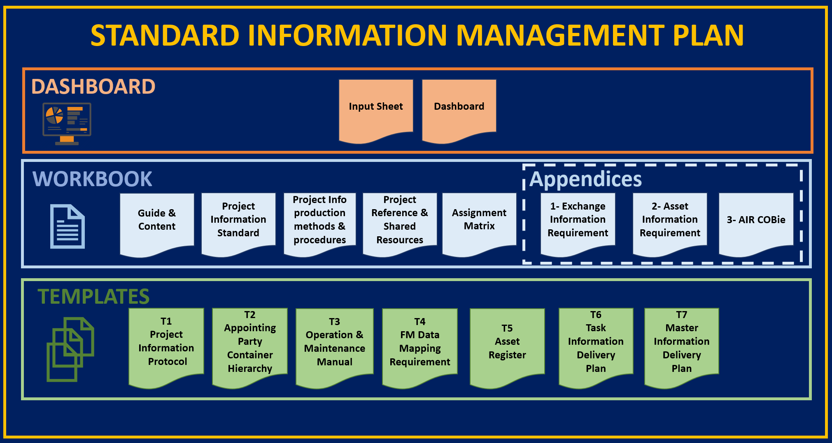
Document overview
Standard Information Management Plan Guidance document
Client Information Manager Scope of Services
Project Information Strategy Dashboard
Standard Information Management Workbook
Template 1 – Project Information Protocol
Template 2 – Appointing Party Information Container Hierarchy
Template 3 – Operation & Maintenance Manuals (inc. H&S file)
Template 4 – FM System Data Mapping
Template 5 – Asset Register
Template 6 – Task Information Delivery Plan
Template 7 – Master Information Delivery Plan

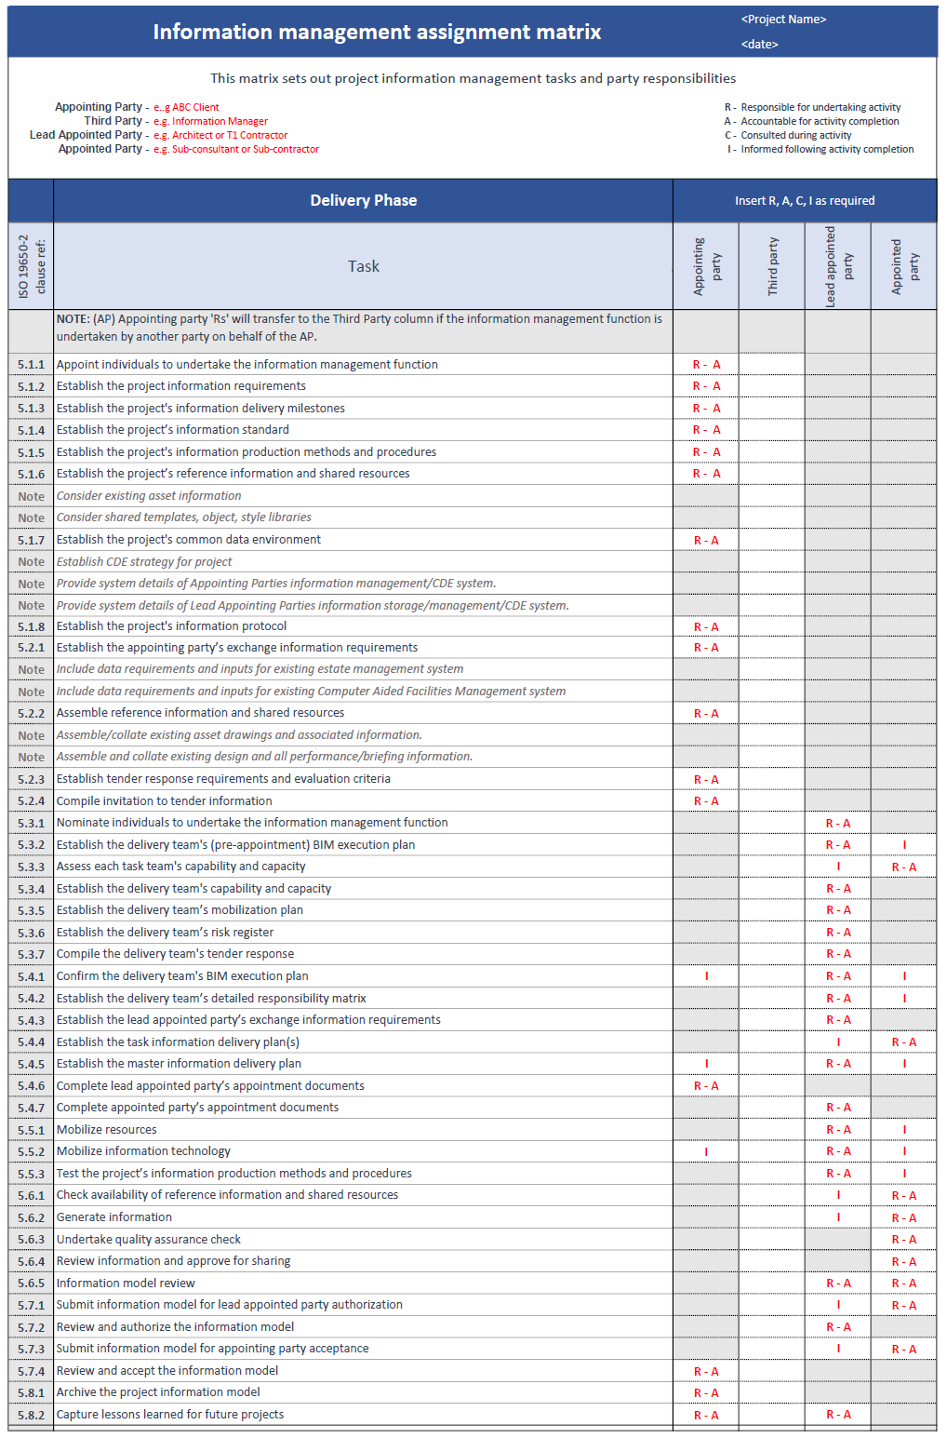
Appendix B – Information management assignment matrix

Appendix C – Project information strategy dashboard
[Add preliminary project information strategy dashboard here]

Appendix D – Terms & Conditions
[Add any contracting authority T&C here]

